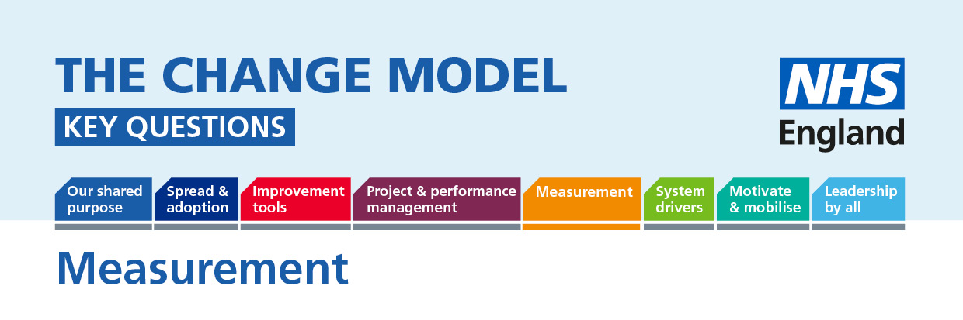

Measurement: If you don’t focus on measurement you won’t know whether progress is being made on the processes we follow and impact being made. We should not be surprised about what we agree to measure, as it should be linked to our shared purpose.
The following questions will help to understand or inform the thinking around the planned change.
Question | Answer (to be completed)
Key Question:
Transparent measurement will help us answer the 'so what' question. Are we measuring the planned and the actual impact of our change correctly?

How can we support patients and staff to help us all understand the whole picture and create a shared ownership for the change needed?

How can we build transparency into our plans to assist shared ownership?
What information are we going to share and with whom and when during this change?
How will we know when our shared purpose has been fulfilled? What milestones will be built into the process to show that we are on track to achieve our shared purpose?

How will we be clear about what is driving the need for change and what contributes to the need to improve quality of care or outcomes and the need to save money?

