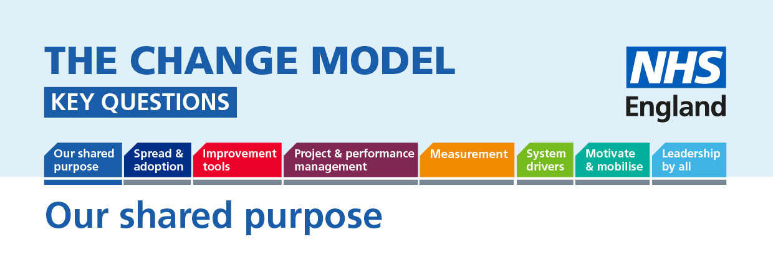

Our Shared Purpose: Developing and agreeing a shared purpose is the fundamental place to start in using the change model in any change process.
The following questions will help to understand or inform the thinking around the planned change.
Question | Answer (to be completed)
Key Question:
Are we co-designing our shared purpose with all the relevant groups? (clinicians, patients and their families, partners across the health and social care system, local business community and community group)

Do we (Staff, patients and the public) jointly own our purpose and how do we know this?

Do we have plans in place to ask and have we listened to the public about what improvements they want to see?

How are patients and public helping to frame the question- what is the problem we are trying to solve?

How can patients help describe the problem we are trying to fix in a way in which it will be clearer and more easily understood for other patients and the public, and how do we capture this?

How are the team showing that we are placing equal value on everyone who will be involved in designing, delivering and benefiting from the change?

How will relationships with patients and the public work during this change process?

How is the power in the relationships being shared equally throughout the change and in all decision making processes to make 'no decision about me without me' a reality?

What do we need to do to assure ourselves (including patients and the public) of the following:
  - we have a shared purpose
  - we are doing this together
  - we are building meaningful relationships

