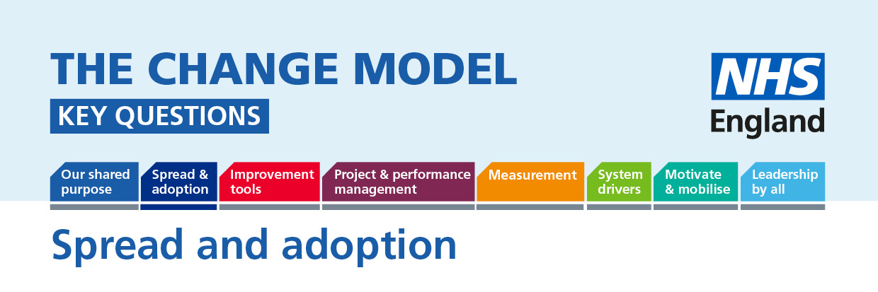

Spread and adoption: This is as much about copying good practice from elsewhere as it is about sharing what is going well for us with others. We all need to share what works, learn from others and spread good practice as well as having new ideas.
The following questions will help to understand or inform the thinking around the planned change.
Question | Answer (to be completed)
Key Question:
How do I get any part of the system to listen to what other organisations are doing well and replicate the good practice?

Do we understand why there are such a range of experiences and service in different parts of the system?
As a patient, how do I get my voice heard when I can see some ways the service could improve?

What are we doing to spread the good practice?
How are patients involved in leading the spread of innovative practice?

How are patients and public being supported in the use of spread and adoption approaches?
How do we reward people for spread and adoption of innovative practice?

