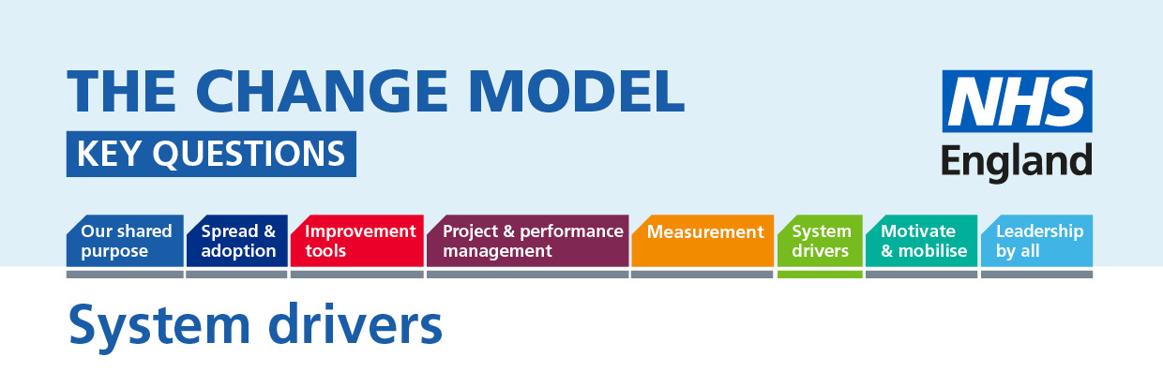

System drivers: The NHS is a complex system with many different parts interacting. Part of the system is the incentives (for example payment systems for providers of care) and sanctions (for instance standards of care and penalties for failing to meet those standards). The incentives and sanctions can drive together to promote change (though sometimes they don’t) and they can operate on a personal or a system level.
The following questions will help to understand or inform the thinking around the planned change.
Question | Answer (to be completed)
Key Question:
What are the incentives for us to support this change?
What is the problem we are trying to fix?
What are the real reasons for change?

